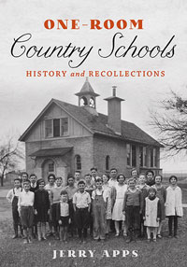

**Book Talk and Signing with Author**

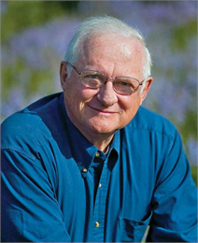

**Jerry Apps**

**Rural Historian**

**Soldiers Grove Library**

**Saturday, April 2, 1:30pm**

**Light Refreshments**

**All Welcome ~ Admission Free**