“Travels with Monique”
Journey through Strasbourg, Munich & Berlin
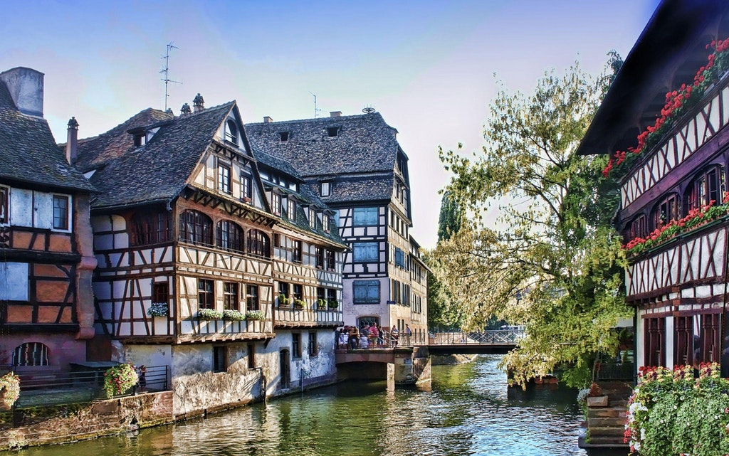
Armchair Travelogue with Monique & Phillip Hooker

Soldiers Grove Library
Thursday, May 10, 5 p.m.
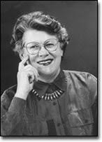

Including a TASTE of Germany!

